St Lawrence College, School of Business
Graduate Certificate Program, Business Analytics
ADMN5003: Data Acquisition, Analysis and Modelling Techniques (Fall 2022)
Assignment 3
12 Marks
- Open book assignment.
- Work independently or in group of 2. Each group submits one assignment.
- Submit a R file on BlackBoard in the folder of “Assignment 3”. Name it as “assign3R_firstname1_firstname2”. Write all your answers and coding in the same file. Clearly label question numbers.
- Late submission penalty is 10% per day.
__________________________________________________________________________________
- For 2 normally distributed populations, assume the significance level is set at 0.05. The two-sided p-value is 0.536. (Total 2.5 marks)
a) What is your null hypothesis of a two-sample t test? (0.5 mark)
b) Is the statistical result significant? (0.5 mark)
c) What will be your decision regarding the null hypothesis? (0.5 mark)
d) What is your alternative hypothesis? (0.5 mark)
e) What is your decision on the alternative hypothesis? (0.5 mark)

- Interpret the following two lift charts. (Total 4.5 marks)
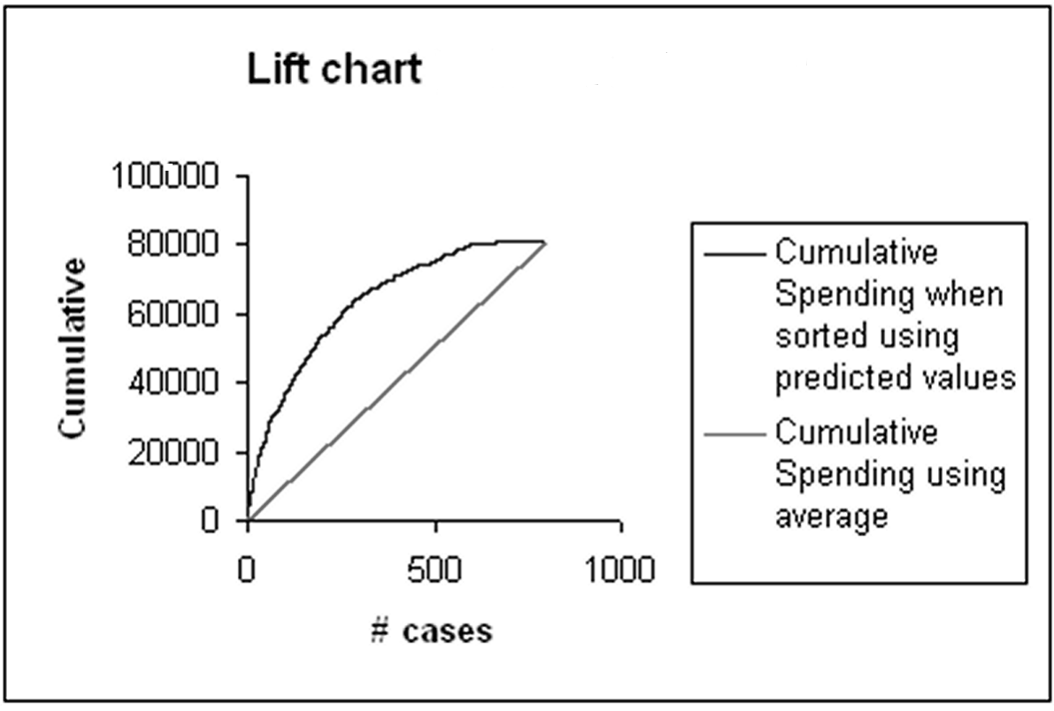
- Is this lift chart generated from a training or a validation dataset? (0.5 mark)
- How is the X axis (cumulative number of cases) sorted? (0.5 mark)
- What does the straight diagonal line and the curved line represent, respectively? (1 mark)
- What does THIS lift chart talk about a model’s predicted performance? (0.5 mark)
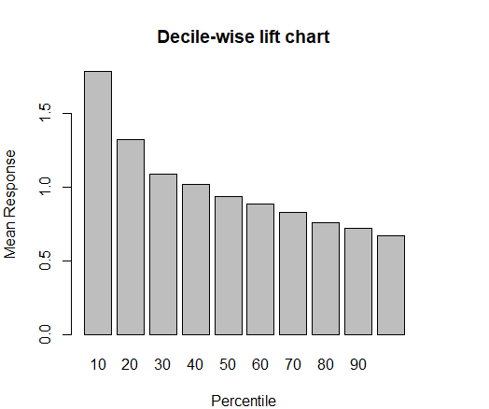

- In this Decile-wise lift chart, what does the Mean Response = 1.0 mean? (0.5 mark) (Hint: it is the mean of what?)
- Interpret the height of the bar in the first 10 percentile. (0.5 mark)
- True or false: lift charts and decile lift charts can evaluate the performance of both prediction analyses (numeric output variable) and classification analyses (categorical output variable). (0.5 mark) Why? (0.5 mark)

- Use the “ownerExample.csv” data, run a R code to generate a confusion matrix based on a cut-off value of 0.5. (1 mark) What is the accuracy? (0.5 mark) (Total 1.5 marks)

- Use all the data in “RidingMowers.csv” (no partition is needed) to answer the following questions (Total 3.5 marks)
- Fit a logistic regression of ownership on the two predictors: Lot size and Income. (1.5 mark)
- The logit as a function of the predictors (0.5 mark)
- The odds as a function of the predictors (0.5 mark)
- The probability as a function of the predictors (0.5 mark)
- Among nonowners, what is the percentage of households classified correctly? Hint: use the function confusionMatrix() in the package caret. (0.5 mark)

